**“Student Attendance Tracker”**

**A EXCEL PROJECT**

**Submitted by**

**Sangay Dendup**

**(22BCA11186)**

***in partial fulfillment for the award of the degree of***

BACHELOR OF COMPUTER APPLICATION



## Chandigarh University

**Introduction**

Attendance is a crucial aspect of academic performance and discipline in any educational institution. Maintaining accurate attendance records helps educators monitor student participation, identify patterns of absenteeism, and ensure compliance with institutional and regulatory requirements. Traditionally, attendance has been recorded manually, which is time-consuming and prone to errors.

This project aims to streamline the attendance recording process by developing a **Student Attendance Tracker.** The tool allows for efficient tracking of daily attendance, automatic calculation of attendance percentages, and visual representation of attendance trends. By utilizing Excel’s powerful formulas, data validation tools, and conditional formatting, the tracker provides a simple yet effective solution for teachers and administrative staff to manage and analyze student attendance data accurately.

The Excel-based system is user-friendly, scalable, and requires minimal technical skills to operate. It reduces the burden of manual calculations, flags students with low attendance, and generates useful insights that can assist in early intervention and better academic planning.

**Objective**

The primary objective of this project is to design and implement a **Student Attendance Tracker** that simplifies and automates the process of recording, calculating, and monitoring student attendance.

**Specific goals include:**

* To create a structured and user-friendly Excel sheet for daily attendance entry.
* To automate the calculation of attendance totals and percentages using Excel formulas.
* To highlight students with low attendance using conditional formatting for easy identification.
* To provide visual representations of attendance data through charts and graphs.
* To support better academic monitoring by enabling quick access to attendance insights.
* To ensure accuracy, minimize manual errors, and save time in maintaining attendance records.

This tool is intended to assist educators and administrators in maintaining consistent, accurate, and efficient attendance management for a classroom or institution.

**Methodology**

The development of the Student Attendance Tracker was carried out in a systematic and structured manner to ensure accuracy, usability, and scalability. Microsoft Excel was used as the primary platform due to its flexibility and built-in features suitable for data management and analysis.

**The methodology followed in this project includes the following steps:**

**1. Planning and Design**

* Defined the structure of the attendance sheet, including columns for roll number, student name, and date-wise attendance entries.
* Decided on a consistent set of attendance codes: P (Present), A (Absent), L (Leave), and H (Holiday).
* Set up a layout that is easy to navigate for daily attendance input.

**2. Data Validation**

* Implemented **Data Validation** on all attendance input cells to allow only specific values (P, A, L, H), reducing human error during data entry.
* Created drop-down menus to select attendance status easily.

**3. Formula Implementation**

* Used Excel formulas like COUNTIF to count the number of days a student was present.
* Calculated attendance percentage with formulas like:  
  = (N2 / 10) * 100
* Added logic using IF to automatically generate remarks for students with attendance below a set threshold (e.g., 75%).

**4. Conditional Formatting**

* Applied **Conditional Formatting** rules to highlight:
  + Attendance percentages below 75% in **red**
  + Attendance percentages above 90% in **green**
  + Absentees (A) in the daily sheet

**5. Charts and Visualization**

* Created **Bar Charts** to visually compare attendance percentages across students.
* Added **Pie Charts** to show overall class attendance distribution (P vs. A).
* Optional: Line charts for date-wise class attendance trends.

**6. Summary and Analysis**

* Added a summary section displaying:
  + Class average attendance
  + Total number of students
  + Number of students with low attendance
  + Highest and lowest attendance percentages

**7. Testing and Review**

* Entered sample data to test formulas and formatting.
* Ensured the system works dynamically (updates as new data is entered).
* Validated that the tool is easy to use and modify for different months or academic sessions.

**Technologies Used**

This project utilizes **Microsoft Excel** as the primary platform to build and manage the Student Attendance Tracker. Excel’s built-in tools, functions, and features provide a powerful environment for creating structured data sheets, performing calculations, and generating visual insights.

**The key technologies and Excel features used in this project include:**

**1. Microsoft Excel**

The core software used for designing, calculating, and visualizing attendance data. Excel provides all necessary tools for efficient attendance tracking without the need for additional software.

**2. Excel Formulas**

* **COUNTIF()**: Used to count the number of times a student is marked present.
* **IF()**: Used to generate conditional remarks (e.g., “Low Attendance” if attendance is <75%).
* **COUNTA()**: Counts non-empty cells to calculate total working days (optional).

**3. Data Validation**

* Used to restrict attendance inputs to specific values: P (Present), A (Absent), L (Leave), and H (Holiday).
* Drop-down menus make data entry easier and prevent manual errors.

**4. Conditional Formatting**

* Highlights students with attendance below a defined threshold (e.g., 75%) in red.
* Applies color codes for present, absent, and leave entries for better readability.

**5. Charts and Graphs**

* **Bar Charts**: Display attendance percentages per student.
* **Pie Charts**: Show the proportion of present vs. absent students.
* **Optional**: Line Charts for trend analysis over time.

**6. Named Ranges (Optional)**

* Used to define reusable named cells or ranges (e.g., total working days) for cleaner formulas and better clarity.

**Implementation/execution**

**Formulas Used:**

* **COUNTIF(D2:M2, "P")**

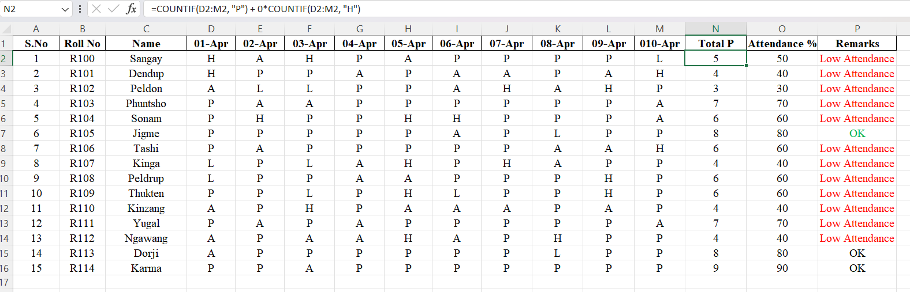

**Explanation:**

* COUNTIF (D2:M2, "P") → Counts all cells marked **P** (Present)
* COUNTIF (D2:M2, "H") → Counts all **H** (Half Days), and multiplies it by 0
* D2:M2 → This is the date range (you can change it based on your actual column range)
* **= (N2 / 10) * 100**

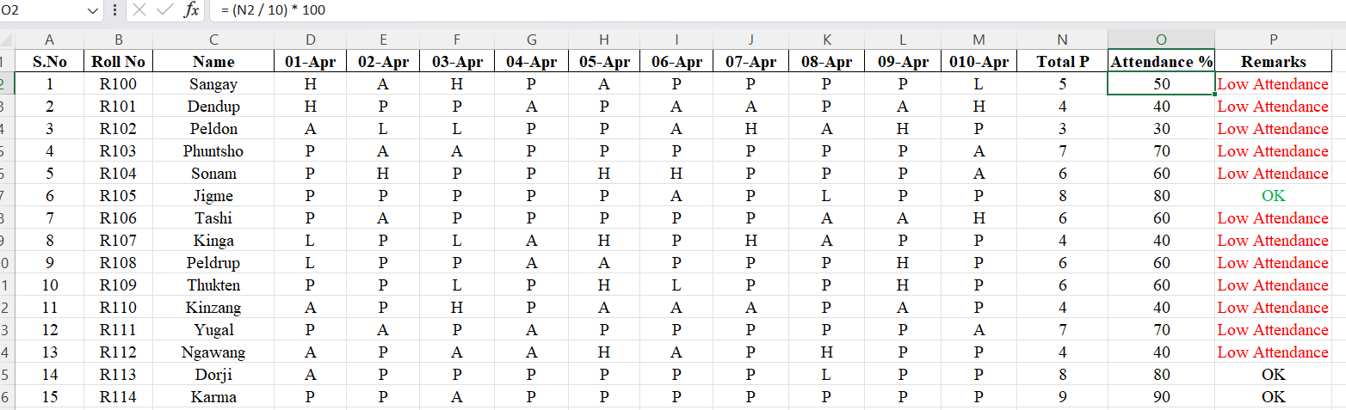

**Explanation:**

* Divides the **Total Presents** by **Total Days**
* Multiplies by 100 to convert to a percentage
* **=IF (O2 >= 75, "OK", "Low Attendance")**

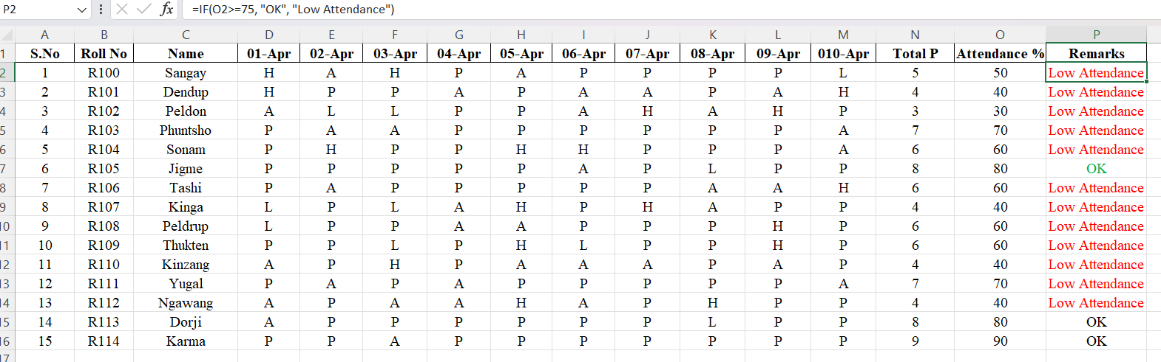

Explanation:

* If attendance is greater than or equal to 75%, it returns "OK"
* Otherwise, it returns "Low Attendance"

Example:

* 80% → "OK"
* 60% → "Low Attendance"

**Dashboard Elements**

* **Pie Chart:** Attendance Overview

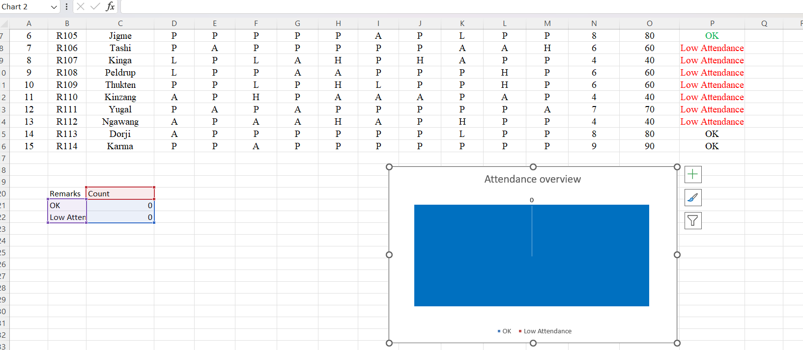

* **Clustered Column Chart: Attendance % per student**

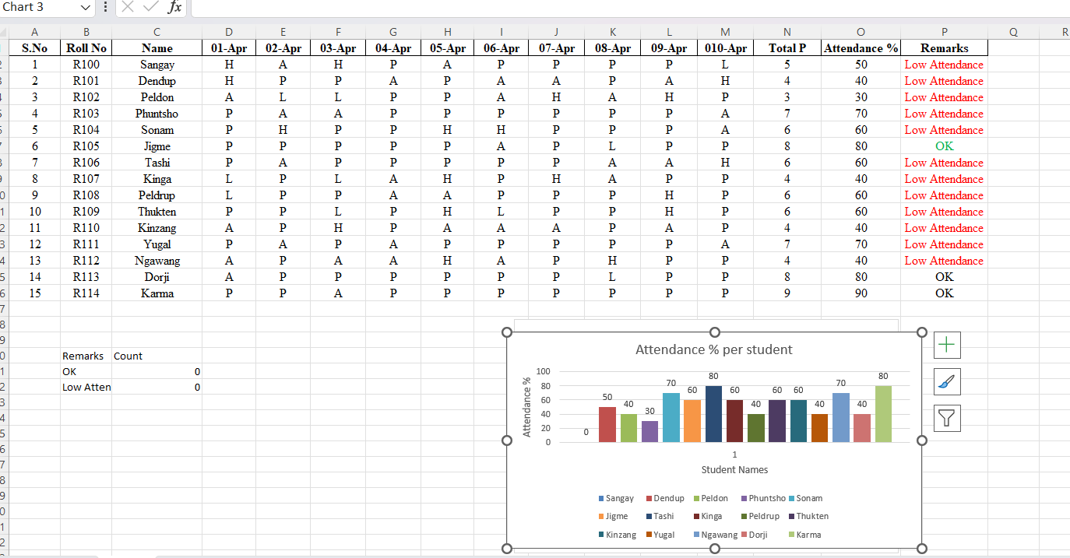

**Conclusion**

The attendance analysis over a 10-day period for 15 students highlights a concerning trend: the majority of students (12 out of 15) fall under the "Low Attendance" category, with attendance percentages below 75%. Only three students — Jigme, Dorji, and Karma — maintained attendance levels considered satisfactory, with Karma achieving the highest at 90%. In contrast, several students, including Peldon, Dendup, Kinga, and Ngawang, recorded attendance below 50%, indicating a need for closer monitoring or intervention. The visual elements, including the pie chart and clustered column chart, clearly depict these trends, making it easier to identify both high-performing and at-risk students. These findings suggest the need for improved attendance strategies, such as counseling sessions, policy reinforcements, and recognition for consistent attendance, to encourage better participation moving forward.

**References**

* Microsoft Excel Official Documentation
* TutorialsPoint Excel Guide
* Microsoft Excel Official Support